**Microservice Using Spring Boot & Spring Cloud | 2 Hours Full Course | JavaTechie**

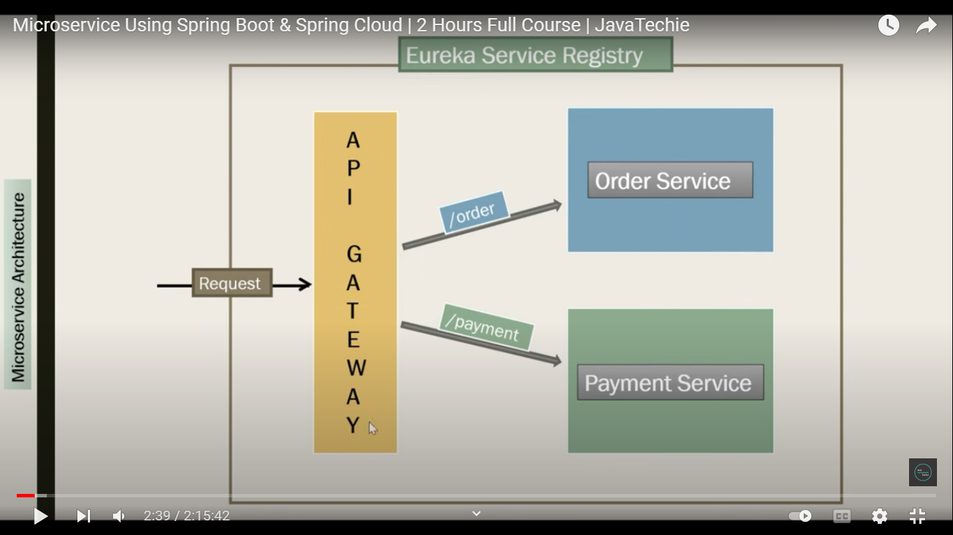

**Spring Cloud Eureka**

**Spring Cloud Gateway**

**Spring Cloud Hystrix**

**Order.Java (Order Service)**

